**CHAPTER 1**

**OVERVIEW**

**Chapter 1 Overview**

**1.1 Introduction**

Healthcare, though a new venture for the Artificial intelligence\ Machine learning domain, remains one of the most crucial domains of public service, one which has been devoted a lot of funding and research. With healthcare, we are possibly looking at the most cardinal and relevant applications of the advanced abilities of Artificial intelligence as well as Machine learning.

With big data growth in biomedical and healthcare communities, accurate analysis of medical data benefits early disease detection, patient care, and community services. However, the analysis accuracy is reduced when the quality of medical data is incomplete. Moreover, different regions exhibit unique characteristics of certain regional diseases, which may weaken the prediction of disease outbreaks [15].

In such a case, it is pertinent that we utilize mathematical modelling to iron out any imperfections and aberrations, so that we have the rigorous standards of accuracy that the medical diagnosis field requires [14].

Artificial intelligence presents challenges due the complexity involved in getting the balance between too much and not enough. We may design systems which can process an extremely wide variety of inputs, but we cannot actively ensure that the AI will respond to it in the way we want it to. It may present us an output which was intended to be for another input, or it may not be able to process it due to the load caused by the heavy processing on the interpreter. Thus, the challenge is not just of input handling or building features, but of efficiency as well.

Medical organisations, all around the world, collect data on various health related issues. These data can be exploited using various machine learning techniques to gain useful insights. But the data collected is very massive and, many a times, this data can be very noisy. These datasets, which are too overwhelming for human minds to comprehend, can be easily explored using various machine learning techniques. Thus, these algorithms have become very useful, in recent times, to predict the presence or absence of heart related diseases accurately.

“Cardiovascular disease is the leading cause of illness and death worldwide,” said Dr. Stephen Weng, of Nottingham University’s National Institute for Health Research School [1]. “Our study shows that artificial intelligence could significantly help in the fight against it by improving the number of patients accurately identified as being at high risk and allowing for early intervention by doctors to prevent serious events like cardiac arrest and stroke.” Based on their results, it is clear that artificial intelligence and machine learning techniques have a key role in fine-tuning risk management strategies for individual patients.

In today's opportunity at numerous spots clinical test outcomes are regularly made in light of specialists' instinct and experience as opposed to on the rich data accessible in numerous expansive databases. Numerous a times this procedure prompts inadvertent predispositions, lapses and a tremendous medicinal expense which influences the nature of administration gave to patients.

Today numerous doctor's facilities introduced some kind of quiet's data frameworks to man-age their social insurance or patient information. These data frameworks commonly produce a lot of information which can be in distinctive organization like numbers, content, diagrams and pictures yet sadly, this database that contains rich data is once in a while utilized for clinical choice making. Like business knowledge and examination, the term information mining can mean diverse things to distinctive individuals. In exceptionally straightforward way we can characterize information mining as this is the investigation of substantial information sets to discover examples and utilize those examples to foresee or fore-cast the probability of future occasions. The motivation to do this problem comes from World Health Organization estimation.

According to the World Health Organization estimation till 2030, very nearly 23.6 million individuals will die because of Heart malady. So, to minimize the danger, expectation of coronary illness ought to be finished. Analysis of coronary illness is typically in view of signs, manifestations and physical examination of a patient. The most troublesome and complex assignment in medicinal services area is finding of right ailment. This colossal entirety huge of rough data is the rule resource that can be capably pre-taken care of and inspected for key information extraction that direct or by suggestion influences the remedial society for cost sufficiency and reinforce decision making. Authentic determination of coronary sickness can't be possible by using simply human understanding. There are heaps of parameters that can impacts the accurate conclusion like less exact results, less experience, time subordinate execution, data up degree and whatnot. Packs of headway and examination happened in this field using multi-parametric qualities with nonlinear and direct parts of Heart Rate Variability (HRV).A novel framework was proposed by Heon Gyu Lee et al. To fulfil this, various experts have used various classifiers e.g. CMAR (Classification Multiple Association Rules), SVM (Support Vector Machine), Bayesian Classifiers and C4.5). A latest's rate techniques in this field depicted. Some plausible strategies and technique we recommended incorporates the clinical information institutionalization, examination and the information sharing over the related industries to improve the precision & viability of information mining applications in social insurance. It is likewise prudent to investigate the utilization of content digging and picture digging for extension the nature and extent of information mining applications in medicinal services part. Information mining application can likewise be investigated on computerized indicative pictures for application viability. Some advancement has been made in these areas.

There is a lot of data put away in stores that can be utilized viably to guide a medical practitioner in decision making in human services. This brings up an essential issue:

"By what means would we be able to transform information into helpful data that can empower medicinal services practitioners to settle on viable clinical decision?"

**1.2 Background**

The heart is an important organ of the human body. It pumps blood to every nooks and corners in our anatomy. If it fails to function correctly, then the brain and various other organs will stop working, and within few minutes, the person will die. Change in lifestyle, work related stress and bad food habits contribute to the increase in rate of several heart related diseases.

Heart diseases have emerged as one of the most prominent cause of death all around the world. According to World Health Organisation, heart related diseases are responsible for the taking 17.7 million lives every year, 31% of all global deaths. In India too, heart related diseases have become the leading cause of mortality [1]. Heart diseases have killed 1.7 million Indians in 2016, according to the 2016 Global Burden of Disease Report, released on September 15,2017. Heart related diseases increase the spending on health care and also reduce the productivity of an individual. Estimates made by the World Health Organisation (WHO), suggest that India has lost up to $237 billion, from 2005-2015, due to heart-related or Cardiovascular diseases [2]. Thus, feasible and accurate prediction of heart related diseases is very important.

The usage of information technology in health care industry is increasing day by day to aid doctors in decision making activities. It helps doctors and physicians in disease management, medications and discovery of patterns and relationships among diagnosis data. Current approaches to predict cardiovascular risk fail to identify many people who would benefit from preventive treatment, while others receive unnecessary intervention. Machine-learning offers opportunity to improve accuracy by exploiting complex interactions between risk factors. We assessed whether machine-learning can improve cardiovascular risk prediction.

While one does come across a lot of AI steeped healthcare software, what one doesn’t see often is these services consolidated as a single package. For users, especially patients on medication or bedrest, it is paramount that they receive care without the vexation of having to juggle between multiple software platforms, annoyed as they already are at having to juggle between medicines and health routines.

**1.3 Importance of the project**

The project aims at creating an intelligent but lightweight healthcare assistant. This application will be able to help healthcare and other hospital staff work efficiently. This also aims at having a basic machine learning capability for disease prediction.

In an era where medical diagnosis and treatment has made massive leaps, it is unfair to deny anyone proper healthcare owing to a lack of means. This project aims to make healthcare less exclusive than it currently is and make it easier to find and avail services.

One often sees a lack of a proper software to help it out in such cases. Software can avoid the necessity of having to revisit doctors, or to spend hours self-researching complex medical terms and appendices, as many diagnosed patients tend to do. The use of a Bot here can automate such mundane tasks and still leave the patient satisfied and assured.

**1.4 Perspective of stakeholders and customers**

Stakeholder perspective is crucial to the success of this project. Part of the reason is that medical diagnosis is a highly sensitive field, and even the slightest of errors, which are evidently unavoidable in even the most sophisticated software, can lead to the patient’s condition worsening. It is also vital to involve the patients, as the patients being comfortable with the equipment, both hardware and software, is necessitous to the smooth working of the technology.

Stakeholders here include

* Doctors and nurses
* Health insurance companies
* Hospitals
* Health department (State as well as National/Federal)
* Biotechnology manufacturers

Doctors and nurses are highly conservative when it comes to adoption of technology, especially software. Due to the sensitivity of the data as well as the need for accuracy, most doctors do not adopt or advise any software, or rather any new technology, until it has been rigorously tested and reviewed by various independent evaluators.

Health insurance companies are much similar to doctors and nurses in this aspect, as there is an extremely large amount of money involved. However, customers looking for health insurance plans were eager for such kinds of technology, evident by the high amount of Google Searches for health insurance plan choosers.

Hospitals were more amenable as well, provided they were supported by the doctors. The use of bleeding edge technology in medical diagnosis is something that many hospitals in California, Massachusetts and New York were willing to try out. Many had, in fact, already done large scale tests on patients.

Health departments have a lot of restrictions on such technology, unless it is being used in a non-invasive way or is complementary to orthodox methods. There are numerous regulations concerning the use of cutting edge technology in the medicinal field.

Biotechnology manufacturing concerns the manufacturing of diagnosis equipment, measuring equipment, support equipment, surgery tools etc. Manufacturers are usually enthusiastic about such technologies. It is also imperative to obtain their support as it makes synchronization between the devices easier.

Potential users, such as those who frequent the forums related to healthcare, wearable technology etc., seemed open to the idea, as anticipated. They seemed to like the idea of a machine learning being used to predict diseases, as well as the other minor features.

**1.5 Objectives and Scope of the project**

The project aims at creating an intelligent but lightweight healthcare assistant. This application will be able to help healthcare and other hospital staff work efficiently. This also aims at having a basic machine learning capability for disease prediction.

The main objective is to offer a way for doctors and patients alike to easily perform mundane healthcare activities as well as advanced prediction services.

We plan to offer various services parallelly. These services include but are not limited to

1. Symptom matching through machine learning

2. Record keeper

3. Group comparison

Besides the features above, we also aim to make the software robust, accurate and fast.

**1.6 Summary**

Healthcare, though a new venture for the artificial intelligence\ Machine learning domain, remains one of the most crucial domains of public service. With big data growth in biomedical and healthcare communities, accurate analysis of medical data benefits early disease detection, patient care, and community services.

It is pertinent that we utilise mathematical modelling to iron out any imperfections and aberrations, so that we have the rigorous standards of accuracy that the medical diagnosis field requires.

The project aims at creating an intelligent but lightweight healthcare assistant. In an era where medical diagnosis and treatment has made massive leaps, it is unfair to deny anyone proper healthcare owing to a lack of means. This project aims to make healthcare less exclusive than it currently is and make it easier to find and avail services. This application will be able to help healthcare and other hospital staff work efficiently.

Stakeholder perspective is crucial to the success of this project. It is also vital to involve the patients, as the patients being comfortable with the equipment, both hardware and software, is necessitous to the smooth working of the technology. Stakeholders here include - Doctors and nurses, Health insurance companies, Hospitals, Health department (State as well as National/Federal), Biotechnology manufacturers.

This application will be able to help healthcare and other hospital staff work efficiently.

This application primarily aims at having a machine learning capability for disease prediction.

The main objective is to offer a way for doctors and patients alike to easily perform mundane healthcare activities as well as advanced prediction services.

**CHAPTER 2**

**Literature Survey & Proposed Work (Phase wise)**

**Chapter 2 Literature Survey & Proposed Work (Phase wise)**

**2.1 Introduction**

Analysis of the current market scenario and technological capabilities is essential to the building of a project. Here we analysed various prevalent research papers pertaining to our project as a part of the literature survey. The project aims at creating an intelligent but lightweight healthcare assistant. This application will be able to help healthcare and other hospital staff work efficiently. This also aims at having a basic machine learning capability for disease prediction.

Our literature survey was focused on the capabilities of the choices we made for the core part of the project, namely artificial neural networks and the use of wearable technology for data collection.

The initial phases focused on the planning and design of the project. We analysed extant products, customer interests and so on. For analysis, we looked at the current iterations of popular and cutting-edge algorithms used in machine learning, such as artificial neural networks and convolutional neural networks. The analysis was openly available in numerous research papers. The design involved comparing the project with some similar projects.

**2.2 Literature Survey Table**

|  |  |  |  |  |
| --- | --- | --- | --- | --- |
| Ref.  No. | Year | Author | Key findings (Results) | Research gaps |
| 1 | April 2017 | Chen, hao, hwang, wang, wang | 1) Big data has grown in healthcare, leading to potential for accuracy in medical analysis.  2) Wearable tech provides new ways to obtain data from patients and monitor their health.  3) A convolutional neural network was used to extract text characteristics.  4) 20 million records from 31 thousand patients were used in the analysis. Records were of three types   * Structured data * Text data * Structured and text   5) The text data is represented in vector format i.e. Word embedding.  6) The multi-model disease risk prediction algorithm gives an accuracy of 94.8%. | 1) Application method for real life healthcare tasks.  2) Methods to improve data structuring for better accuracy. |
| 2 | January 2017 | Chen, Ma, Li, Wu, Zhang, Youn | 1) Washable smart clothing consists of sensors, electrodes, and wires.  2) Advanced methods of data retrieval are combined with advanced methods of data analytics and cognitive computing.  3) Body temperature sensor is put in the underarm seam; a set of ECG sensors are mounted on the chest, shoulders, and ribs; the myocardial sensor is embedded in the left part of the chest; and the SpO2 sensor is deployed on the triceps.  4) The data is dependent on the emotional state of the subject.  5) 2 layers of storage are used, the first on local devices and the second on the high-level clouds for advanced processing. | 1) A proper method to collect data without making the user uncomfortable.  2) Usage of algorithms to handle data processing and compression. |
| 3 | March 2015 | S. Vijayarani, S.Dhayanand | 1) The healthcare industry collects huge amounts of healthcare data  2) This data was used to train a system running SVM and ANN algorithms. | 1) Methods to improve classification accuracy |
| 4 | November 2016 | Abadi, Barham, Chen, Dean, Devin, Warden, Ghemawat, Irving, Isard, Kudlur, Chen, Monga, Moore, Murray, Davis, Vasudevan | 1) Tensorflow is a large-scale, heterogeneous machine learning system, which uses dataflow graphs to represent computation.  2) Tensorflow is a descendant to DistBelief, which Google has used since 2011  3) Many neural networks are trained using stochastic gradient descent  4) Tensorflow works across a distributed GPU architecture to maximize efficiency. | 1) Methods to improve classification accuracy |
| 5 | June 2016 | Yong-Young Kim, Mi-Hye Kim | 1)Software developers & medical experts believe that health monitoring and the prevention of diseases should be explored.  2) Absence of certifications for healthcare software is still a concern | 1) Societal acceptance of automized healthcare  2) Specification of anticipated problems |
| 6 | October 2014 | Jürgen  Schmidhuber | 1) A standard neural network (NN) consists of many simple, connected processors called neurons  2) Re-cyclic neural networks are the deepest of all neural networks | 1) Constraints in application |
| 7 | November  2014 | Kouroua,  Exarchos,  Exarchos,  Karamouzis, Fotiadis | 1) Machine learning techniques are being utilized to model the progression and treatment of cancerous conditions.  2) It uses methods like Artificial neural networks, Support vector machine, Decision trees and Bayesian networks. For evaluating the performance, it uses Holdout method, random sampling, Cross validation and Bootstrapping. | 1) Application method for real life cancer detection.  2) Validation accuracy of algorithm. |

**Table 1: Literature survey**

**2.3 Problem definition (Phase wise)**

We have divided the project into 2 phases, which are further divided into 5 and 2 sub-phases each. The problem definitions for each phase and sub-phase are as follows.

Phase I – Phase I will focus on forming a base for the project. With thorough planning, analysis and design, we will ensure that the actual implementation is smoother.

1. Planning: Applying agile methodology for planning our healthcare software project, and to achieve better results in the time frame given to us, along with better flexibility.
2. Analysis: Prepare an analysis of our own project. Prepare a detailed analysis on present healthcare assistants and overcoming its limitation and performance benchmarks.
3. Design: Integration of data and designing of event system app.
4. Coding: Writing the whole system app code and taking help of open source.
5. Implementation: Giving user to test alpha testing and gathering centric analysis of performance, feedback, and try to improve the quality of the result/output

Phase II – Phase II will focus on fine tuning the project and ensuring that the intended features will work as we wanted them to.

1. Testing: Doing the various test on system app like as Unit testing, Integration testing, Regression testing, system testing, etc., of test case data to check if the Integrated system functions are as desired by the client.
2. Deployment: Conduct beta testing for identifying any further errors, bugs and improvements that can be performed. After testing and approval, deploy the proposed system.

**2.4 Feasibility study**

Economic feasibility

The project relies on open source software, such as python, R, NumPy and SciPy. The functionality provided by these software’s is enough to construct a product capable of usage for healthcare applications.

For the machine’s learning and training, we will use freely available datasets. These sets run into thousands of lines, and thus can provide enough learning capability to the software. Due to these 2 being freely available, the project is very low cost and thus feasible from an economic standpoint.

The expected total cost is thus 0 rupees. As such, we do not need any outside funding. The project will be expected to make minimal sales, if sold commercially, due to the presence of a variety of other similar tool and the slow adaption of software’s by the medical community.

Technical

The capabilities required for the project are fairly in the feasible range. Most of the planned feature hinge around processing datasets. A GUI is required, which will be done with the pyGUI framework. The GUI will be kept simple and minimalist. For the hospital searching and insurance selection, we will use readily available data. We also have a feature for users to set personal data, preferences.

For the machine learning, we will use Neural networks to train our datasets, both of which are available on open source repositories.

Operational

On an operational level, the software will need to run intensive processing tasks while it’s in its learning phase. Since the learning phase is a very short process, it is doable without the need for extra hardware. The software will be deployed as a Desktop application and will need users to download it. It will also need internet to operate.

Socio-cultural

This application will have many positive applications on society. It will enable users to manage their healthcare needs in a cheap and easy way. Users with chronic illnesses will find it especially helpful. Those with financial problems will also find it helpful.

Some users may not be willing to accept automated healthcare, but most would be willing. Since it reduces the need for health monitoring, users living in areas with costly healthcare (e.g. most of the USA) will find it helpful. Also, the sharing of instantly available, accurate information can make the difference between life and death.

Legal

Since the project deals with a sensitive topic with potential for major harm, it will carry a disclaimer for improper usage. The software is not meant to be a substitute for doctors or hospital provided healthcare. Users should ideally only use it to supplement professional healthcare. However, the potential for misuse, whether intentional or not, still exists.

Much has been said about the ethical advantages of free software in general, and it is particularly true in a profession in which the sharing of instantly available, accurate information can make the difference between life and death. As medical software begins to offer decision support, risk management, performance rating, and analytic features, physicians should learn to be more careful with its usage.

Ethical

While the software is meant to help users with their health, there still is potential for improper usage leading to damage. The software should not be used as a substitute for doctors or professionally provided healthcare. Users must only use it to supplement the same. Much has been said about the ethical advantages of “free” software in general, and it is particularly true in a profession in which the sharing of instantly available, accurate information can make the difference between life and death.

As medical software begins to offer decision support, risk management, performance rating, and analytic features, physicians should not accept black boxes and secret formulas that constrain sharing and intimately affect patient care and reimbursement.

**2.5 Methodology used**

The methodology that we chose for our project is Agile. While waterfall model is a tried and tested framework, it is not suitable for our project, due to the changeable nature and small team size. Agile allows us to be flexible, manage changing requirements, manage the ever-increasing scope as well as get consumer perspective.

Agile has focus on customer satisfaction, which is a crucial aspect of any healthcare application. Patients, insurance providers and doctors need to be clued in to the process for the indispensable inputs they can provide.

**2.5.1. Agile**

Agile software development is a methodology for software projects under whose framework project requirements and solutions evolve through the collaborative effort of self-organizing and cross-functional teams and their customer and intended users. It advocates for flexible modelling and planning, flexible implementation, rapid delivery of code, and constant improvement, and it advocates speedy and flexible reactions to change.

**12 Agile Principles**

1. Our highest priority is to satisfy the customer through early and continuous delivery of valuable software.
2. Welcome changing requirements, even late in development. Agile processes harness change for the customer's competitive advantage.
3. Deliver working software frequently, from a couple of weeks to a couple of months, with a preference to the shorter timescale.
4. Business people and developers must work together daily throughout the project.
5. Build projects around motivated individuals. Give them the environment and support they need and trust them to get the job done.
6. The most efficient and effective method of conveying information to and within a development team is face-to-face conversation.
7. Working software is the primary measure of progress.
8. Agile processes promote sustainable development. The sponsors, developers, and users should be able to maintain a constant pace indefinitely.
9. Continuous attention to technical excellence and good design enhances agility.
10. Simplicity - The art of maximizing the amount of work not done--is essential.
11. The best architectures, requirements, and designs emerge from self-organizing teams.
12. At regular intervals, the team reflects on how to become more effective, then tunes and adjusts its behavior accordingly.

**2.5.2 Customer interaction details**

We used forums as the main source of our customer input. AI forums as well as healthcare forums are buzzing with activity. Users showed interest in Machine Learning based prediction of diseases, as well as a software that can do it for a reasonable cost.

Besides this, we researched interests of customers in wearable technologies. Technologies like Fitbit have already made a splash in the healthcare market. Users of Fitbit displayed interest in software products that could help them better utilize the data that it was gathering.

**2.6 Summary**

Here we analysed various prevalent research papers pertaining to our project as a part of the literature survey. The project aims at creating an intelligent but lightweight healthcare assistant. This application will be able to help healthcare and other hospital staff work efficiently.

Our literature survey was focused on the capabilities of the choices we made for the core part of the project, namely artificial neural networks and the use of wearable technology for data collection.

We have divided the project into 2 phases, which are further divided into 5 and 2 sub-phases each. The problem definitions for each phase and sub-phase are as follows.

Phase I – Phase I will focus on forming a base for the project. With thorough planning, analysis and design, we will ensure that the actual implementation is smoother.

Phase II – Phase II will focus on fine tuning the project and ensuring that the intended features will work as we wanted them to.

Due to these 2 being freely available, the project is very low cost and thus feasible from an economic standpoint.

The expected total cost is thus 0 rupees. As such, we do not need any outside funding.

The capabilities required for the project are fairly in the feasible range. Most of the planned feature hinge around processing datasets. A GUI is required, which will be done with the pyGUI framework. The GUI will be kept simple and minimalist. For the hospital searching and insurance selection, we will use readily available data. We also have a feature for users to set personal data, preferences. On an operational level, the software will need to run intensive processing tasks while it’s in its learning phase.

This application will have many positive applications on society. It will enable users to manage their healthcare needs in a cheap and easy way. Since the project deals with a sensitive topic with potential for major harm, it will carry a disclaimer for improper usage. The software is not meant to be a substitute for doctors or hospital provided healthcare. Users should ideally only use it to supplement professional healthcare. However, the potential for misuse, whether intentional or not, still exists.

The methodology that we chose for our project is Agile. Agile allows us to be flexible, manage changing requirements, manage the ever-increasing scope as well as get consumer perspective. Agile has focus on customer satisfaction, which is a crucial aspect of any healthcare application.

Agile software development is a methodology for software projects under whose framework project requirements and solutions evolve through the collaborative effort of self-organizing and cross-functional teams and their customer and intended users.

Users showed interest in Machine Learning based prediction of diseases, as well as a software that can do it for a reasonable cost.

Besides this, we researched interests of customers in wearable technologies. Technologies like Fitbit have already made a splash in the healthcare market.

**CHAPTER 3**

**Analysis and planning**

**Chapter 3 Analysis and planning**

**3.1 Introduction**

The analysis phase is the most crucial phase of any project. The quality of the analysis can make or break a project. Artificial intelligence presents challenges due the complexity involved in getting the balance between too much and not enough. Planning such a task is matter of finding what we really need and we don’t.

We may design systems which can process an extremely wide variety of inputs, but we cannot actively ensure that the AI will respond to it in the way we want it to. It may present us an output which was intended to be for another input, or it may not be able to process it due to the load caused by the heavy processing on the interpreter. We have to plan for such a scenario too. Thus, the challenge is not just of input handling or building features, but of efficiency as well.

We did this phase slowly so we be could be thorough with all our requirements and plans. A slow approach also allowed us to anticipate risks. Planning phase is probably the best time to plan for risks and avoid them altogether. Being careful in the planning phase allows us to put less effort into the risk mitigation, risk monitoring and risk management plan.

**3.2 Product Backlog or Sprint backlog**

The backlog of the project is given as follows:

**Tasks to be Done:**

* Make GUI for main features
* Make GUI for fringe features
* Add a symptom matching feature
* Make a checklist database for users
* Add a comparison feature
* Obtain global data for patients to compare with

**Ongoing Tasks:**

* Information catalogue building
* Dataset training
* Basic GUI building
* Procurement of more medical data for higher accuracy

**Tasks Done:**

* Analysis
* Design
* Modelling
* Literature survey
* Budgeting and scheduling
* Feasibility analysis

**3.3 Project planning (Resources, Tools used, etc.)**

IT projects require resources in terms of money, time, human resources, infrastructure and technology, both hardware and software. Resources are not just a mean, but also an approximation of constraints.

Project planning is essential to managing the scope, schedule and budget of the project. For this, we used tools such as MS Excel, MS PowerPoint, online MS project as well as various modelling tools, such as draw.io.

Stakeholder perspective is crucial to the success of this project. Part of the reason is that medical diagnosis is a highly sensitive field, and even the slightest of errors, which are evidently unavoidable in even the most sophisticated software, can lead to the patient’s condition worsening.

Thus, we made it a necessity to search for user consensus before we planned for features to be built in our project. This was done by researching search interest on search engines, visiting forums pertaining to machine learning, artificial intelligence, healthcare as well as wearable technology. We divided our project into various phases and sub-phases, and allocated date ranges from a week to 3 weeks to every sub-phase. This was done using the timeline chart feature of online MS project. We then used a Gannt chart to model schedule dependencies and fine tune the scheduling. The Gantt chart was created using the Gantt chart feature available in MS Excel. Using these two, we further planned our sub-phases.

The modelling included charts and diagrams such as UML diagram, GUI modelling, dependencies and other diagrams. These were done using free tools like draw.io. Drawing these models helped to incisively assess our requirements and features.

**3.4 Scheduling (Time line chart or Gantt chart) according to sprint backlog**

|  |  |  |
| --- | --- | --- |
| **Task** | **Duration** | **No. of days** |
| Project charter | 6/1/2019 - 10/1/2019 | 1 |
| Requirement gathering | 13/1/2019 - 17/1/2019 | 1 |
| Security planning | 20/1/2019 - 24/08/2019 | 1 |
| Legal planning and user survey | 27/1/2019 - 31/1/2019 | 1 |
| Implementation and testing of basic functionality | 3/2/2019 - 21/2/2019 | 5 |
| Implementation and testing of GUI | 23/2/2019 - 14/3/2019 | 5 |
| Implementation and testing of machine learning functionality | 14/3/2019 - 28/3/2019 | 7 |

**Table 3.4: Timeline chart table**

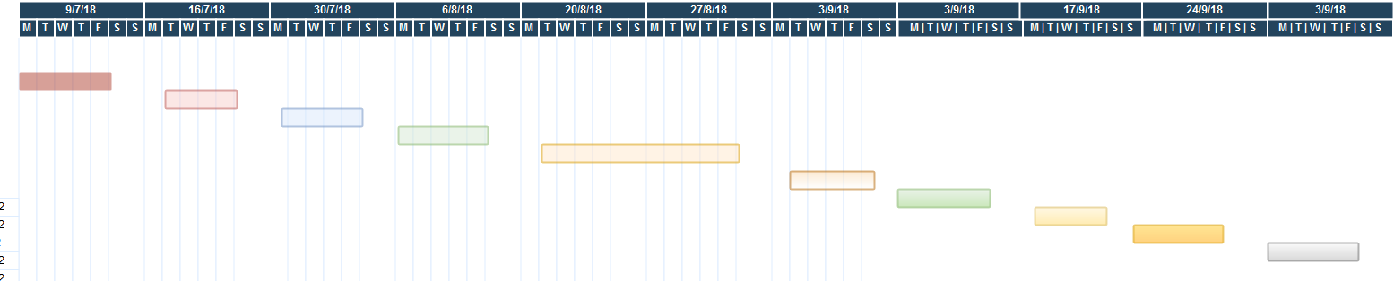

**Figure 3.4: Timeline Chart**

**Gantt Chart**

|  |  |  |
| --- | --- | --- |
| **Task** | **Duration** | **No. of days** |
| Project charter | 6/1/2019 - 10/1/2019 | 1 |
| Requirement gathering | 13/1/2019 - 17/1/2019 | 1 |
| Security planning | 20/1/2019 - 24/08/2019 | 1 |
| Legal planning and user survey | 27/1/2019 - 31/1/2019 | 1 |
| Implementation and testing of basic functionality | 3/2/2019 - 21/2/2019 | 5 |
| Implementation and testing of GUI | 23/2/2019 - 14/3/2019 | 5 |
| Implementation and testing of machine learning functionality | 14/3/2019 - 28/3/2019 | 7 |
| Project presentation | 28/3/2019 – 1/4/2019 | 1 |
| Final submission of Black-book | 11/4/2019 - 17/4/2019 | 4 |

**Table 3.5: Timeline chart table**

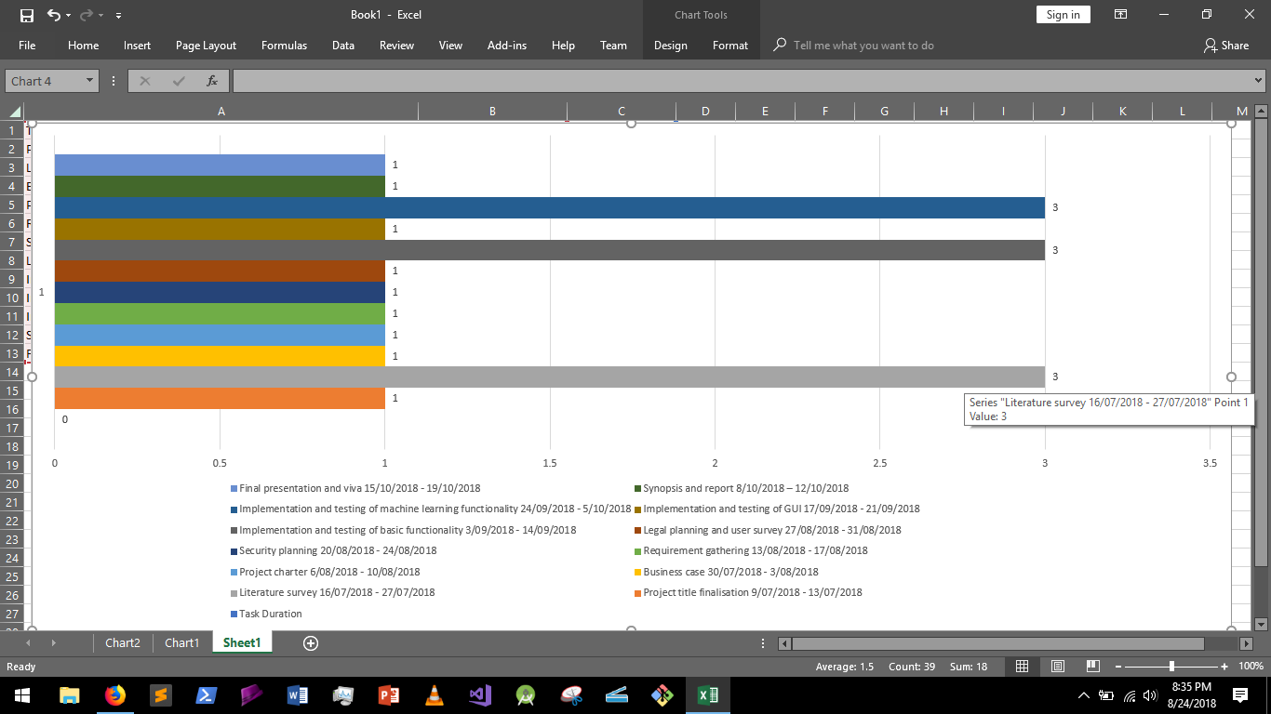

**Figure 3.5: Bar chart**

**3.5 Summary**

Here we summarize the analysis and planning phase of our project. The phase included scheduling, budgeting and creation of subtasks. The subtasks help us properly define our needs and features.

The analysis phase is the most crucial phase of any project. The quality of the analysis can make or break a project. Artificial intelligence presents challenges due the complexity involved in getting the balance between too much and not enough. Planning such a task is matter of finding what we really need and we don’t.

We did this phase slowly so we be could be thorough with all our requirements and plans. A slow approach also allowed us to anticipate risks.

The product backlog was divided into three phases - to do, ongoing and done.

The to do phase included - Make GUI for main features, make GUI for fringe features, add a symptom matching feature, make a checklist database for users, add a comparison feature, obtain global data for patients to compare with.

The ongoing tasks were - information catalogue building, dataset training, GUI building, procurement of more medical data for higher accuracy.

The tasks which were already done were - analysis, design, modelling, literature survey, budgeting and scheduling, feasibility analysis.

Project planning is essential to managing the scope, schedule and budget of the project. For this, we used tools such as MS Excel, MS PowerPoint, online MS project as well as various modelling tools, such as draw.io.

Stakeholder perspective is crucial to the success of this project. Part of the reason is that medical diagnosis is a highly sensitive field, and even the slightest of errors, which are evidently unavoidable in even the most sophisticated software, can lead to the patient’s condition worsening. Thus, we made it a necessity to search for user consensus before we planned for features to be built in our project.

The scheduling included a plan for the first half of the year. The plan includes - project title finalization, literature survey, business case, project charter, requirement gathering, security planning, legal planning and user survey, implementation and testing of basic functionality, implementation and testing of GUI, implementation and testing of machine learning functionality, synopsis and report and final presentation.

**CHAPTER 4**

**Design and Implementation**

**Chapter 4 Design and Implementation**

**4.1 Flowchart**

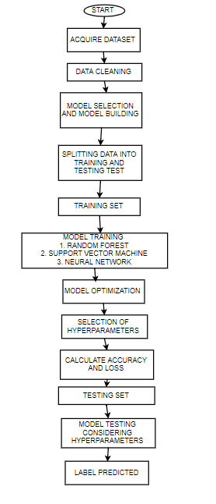

**Flowchart 4.1: Workflow of application**

**4.2 UML diagram**

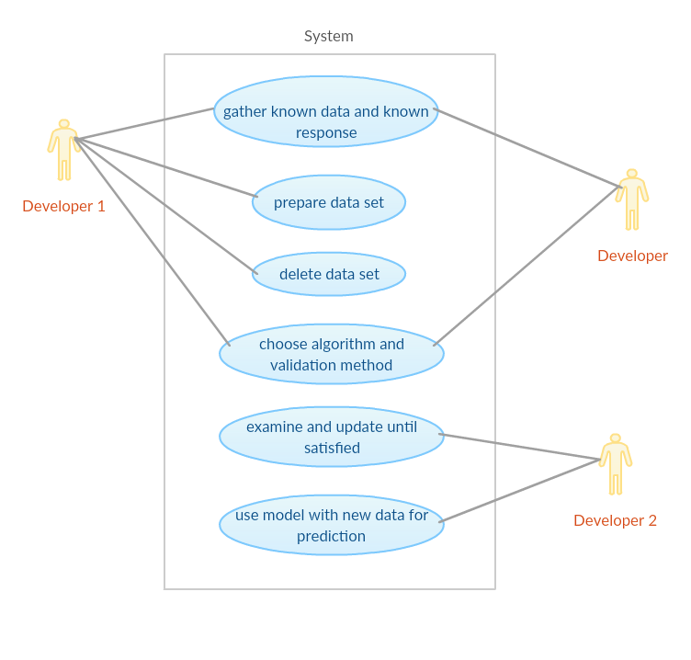

**Figure 4.2: UML Diagram**

**4.3 GUI**

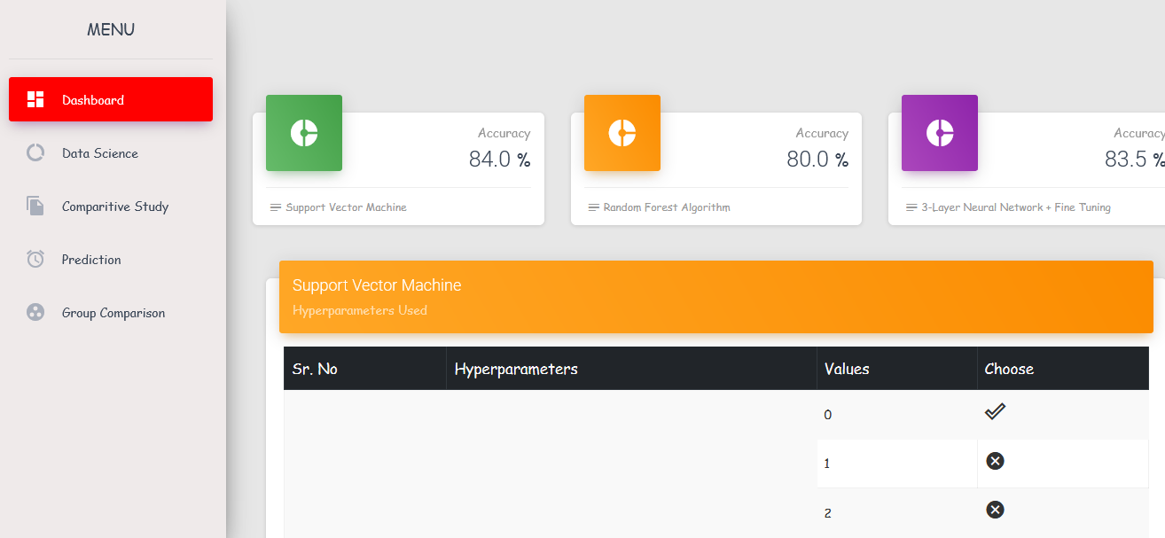

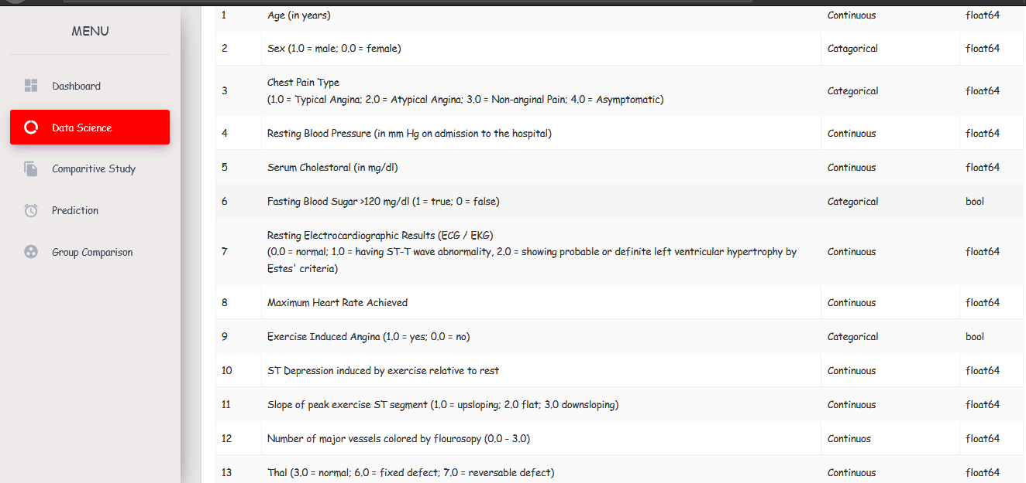

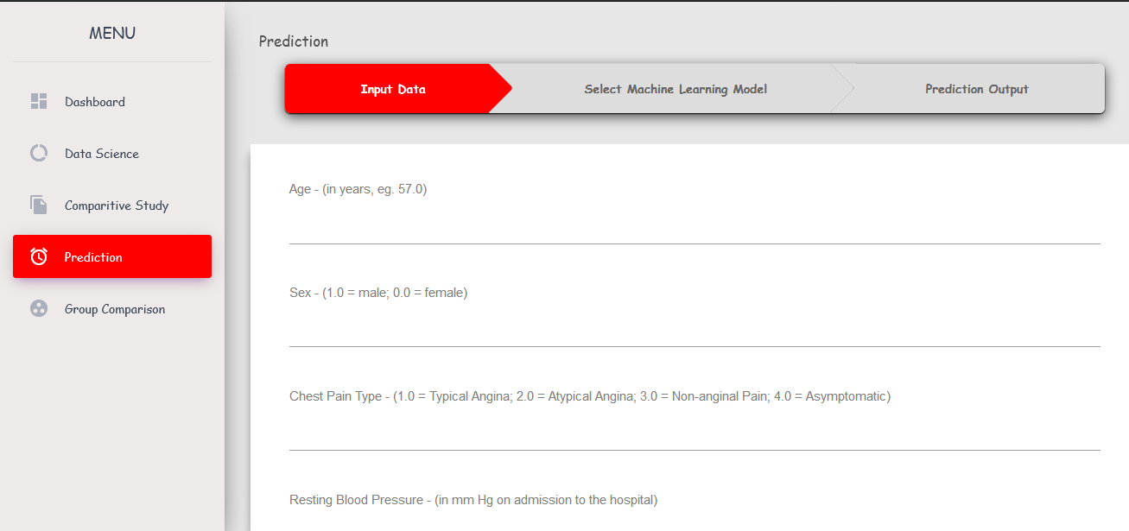

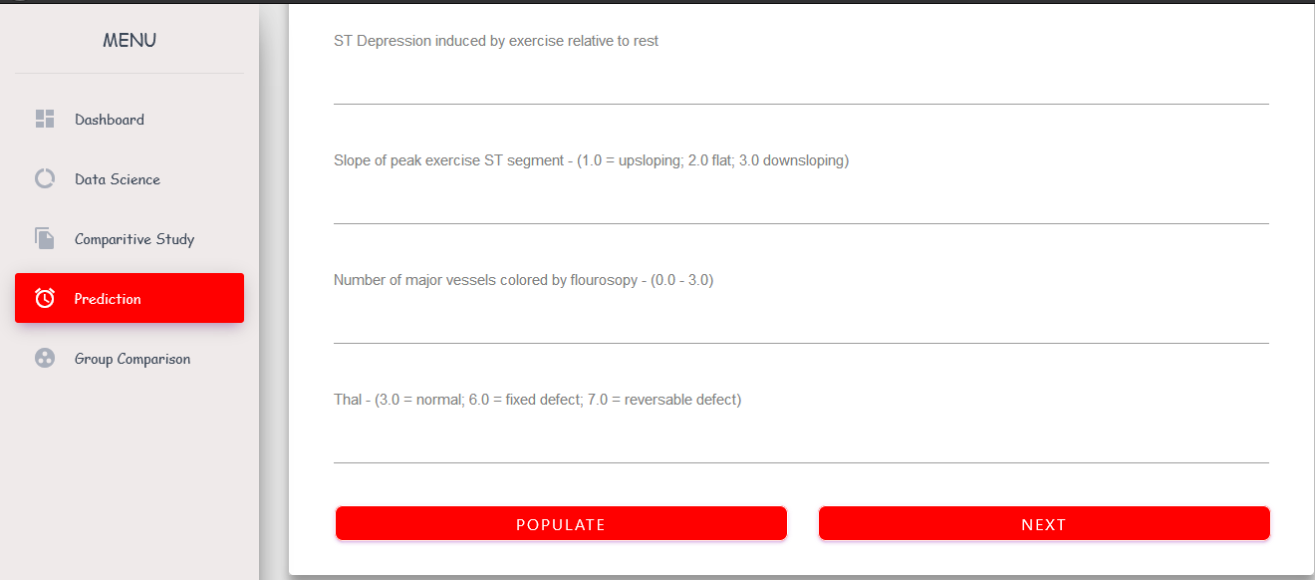

**CHAPTER 5**

**Results & Discussion**

**Chapter 5 Results & Discussion**

**5.1 Actual Results**

Outputs:

Our software has adequate machine learning capabilities. We were also able to build a GUI for web implementation.

The algorithms used for implementing machine learning are

* SVM (Support vector machines)
* Random forest
* Neural network (3-layered)

Of these, we got our best results with 3-layered Neural network, which gave us an accuracy of 94.39%. SVM and random forest gave accuracies of 84% and 80% respectively. This was trained and tested on publicly available data. Doctors who can provide access to large swathes of confidential patient data can make it even more accurate.



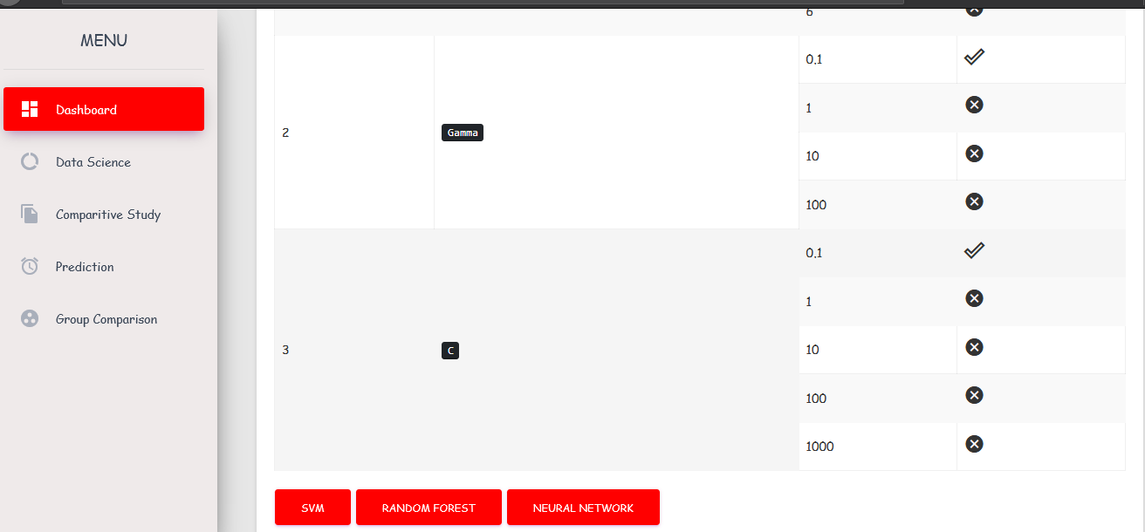

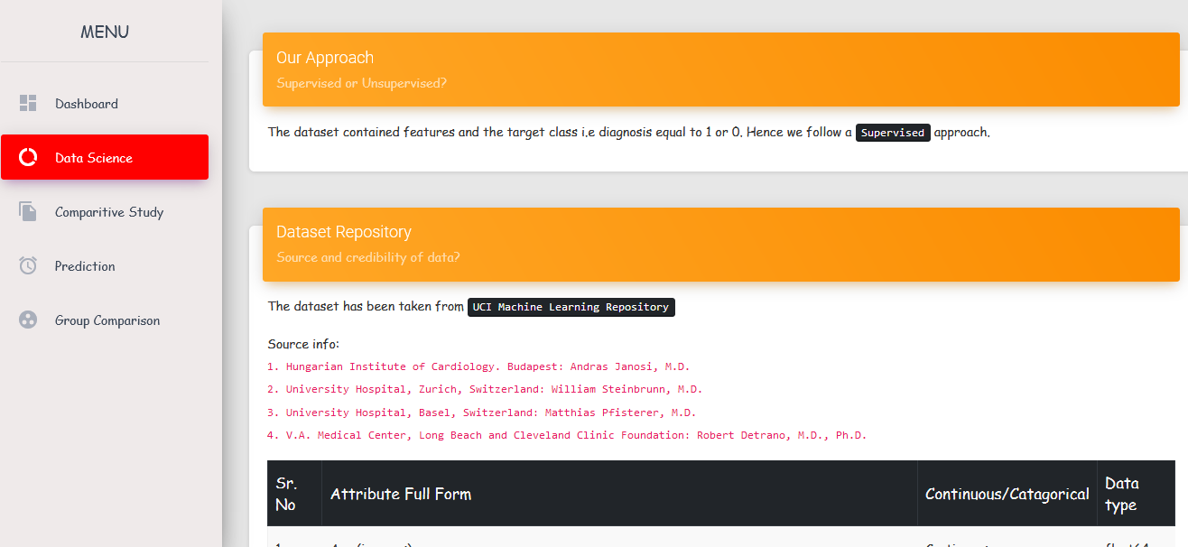



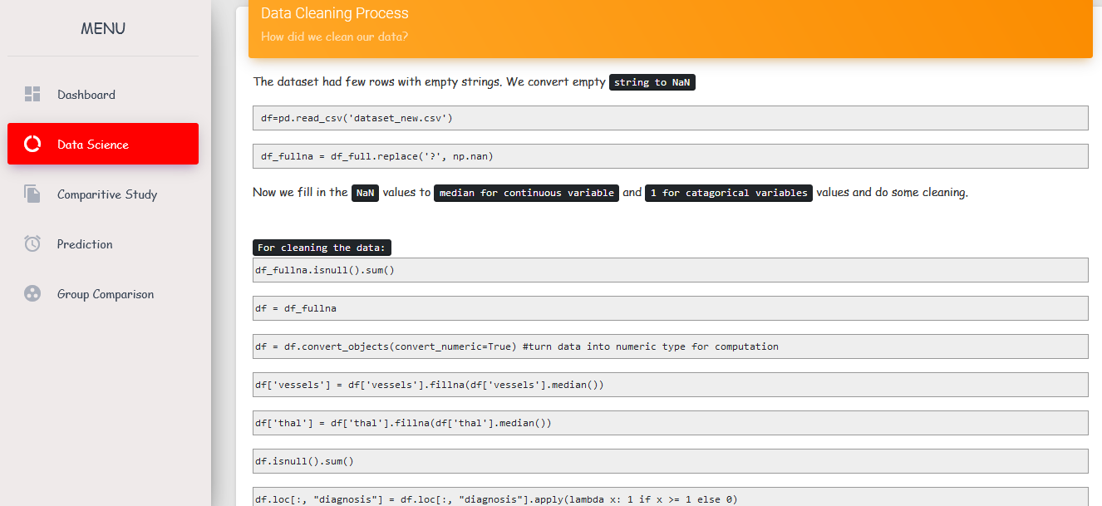

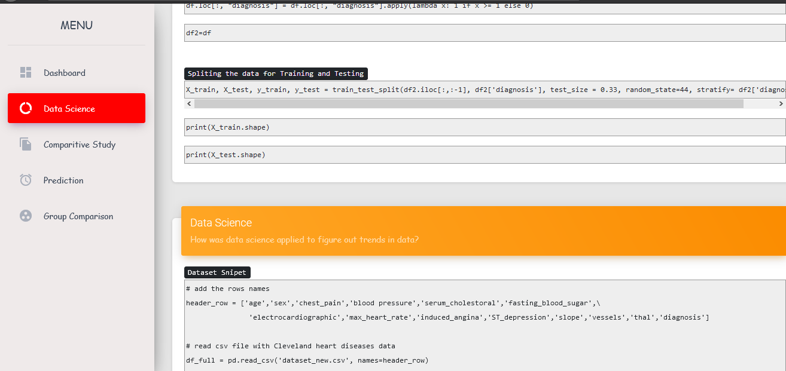

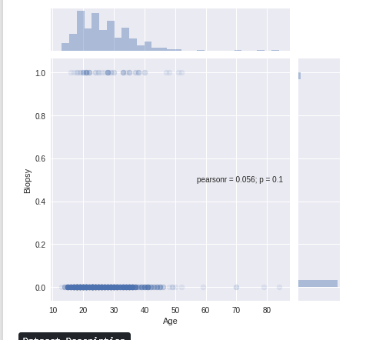 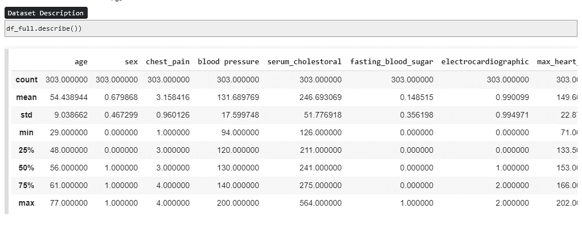

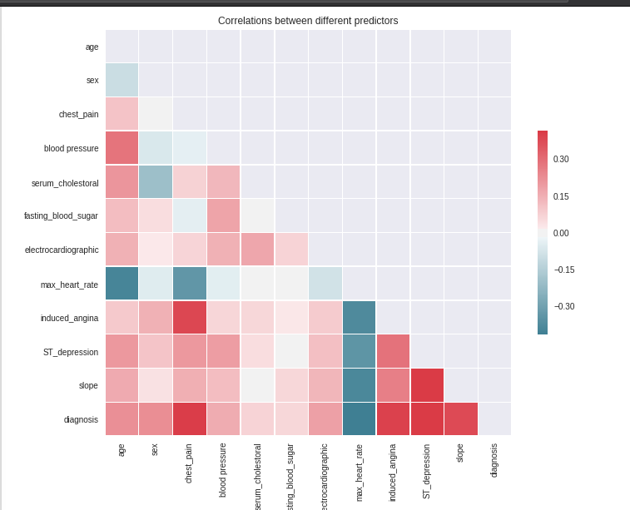

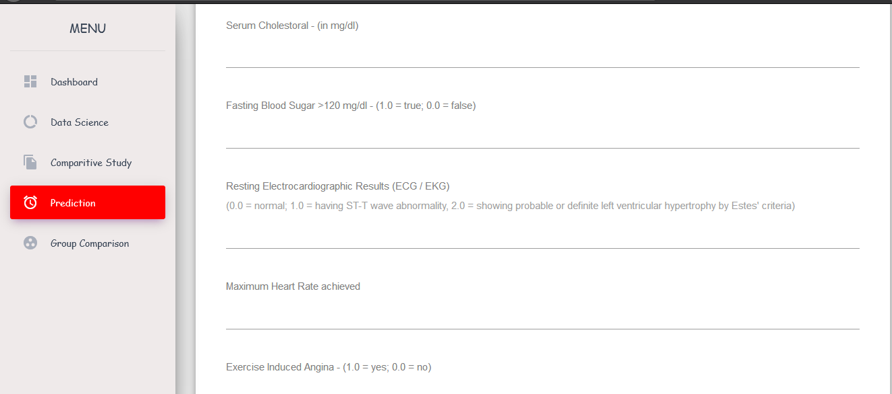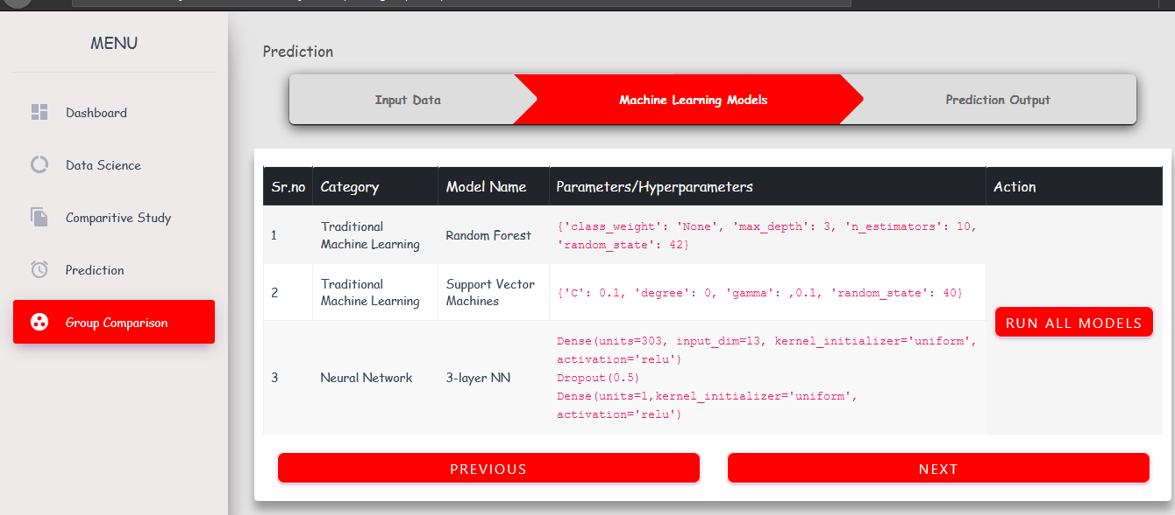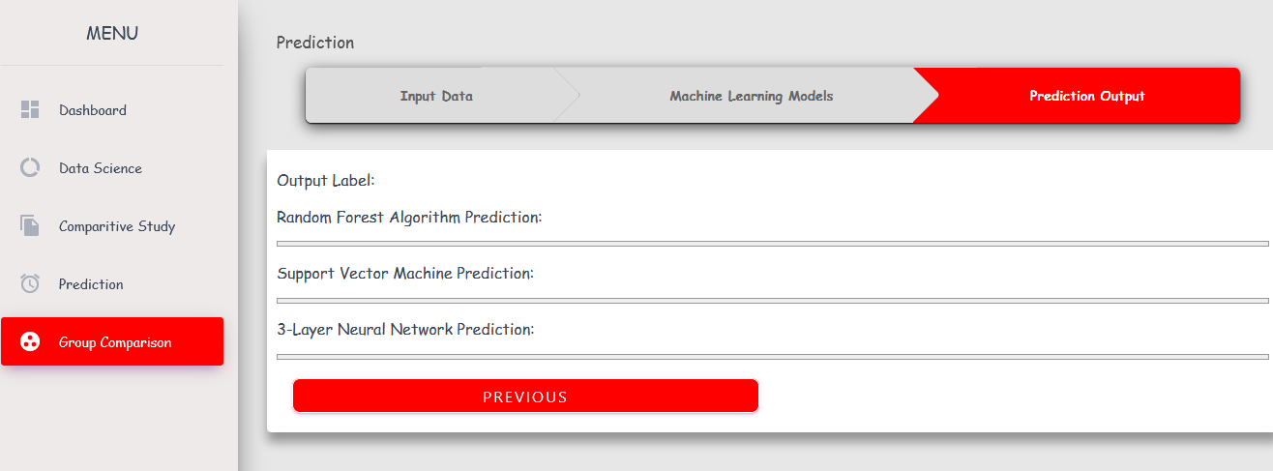



Outcomes:   
The project intends to correctly analyse the input data on the basis of 14-16 parameters to correctly judge the presence of the disease. It uses complex algorithms like Random Forest, SVM, and 3-layered NN. It gives us an accuracy value of up to 94.39%, which is certainly high for models trained with publicly available data.

Discussion:

AI systems are now a part of a variety of specializations from stock trading to the setting of real estate prices; from fraud detection to translation of vernacular languages; from designing our daily shopping lists to forecasting which movies we might like and diagnosis of medical condition.

This is merely the beginning. Not long from today, AI will be used to advance our understanding of biological phenomenon through analysis of highly dense and huge datasets, help us invent new drugs and make treatments more thorough and personal. Self-driving vehicles can revolutionize transportation and allow new paradigms in planning of architecture. Machines will run our homes more efficiently, make businesses more productive and help predict risks to society.

Before AI systems can be deployed in healthcare applications, they need to be ‘trained’ through data that are generated from clinical activities, such as screening, diagnosis, treatment assignment and so on, so that they can learn similar groups of subjects, associations between subject features and outcomes of interest. These clinical data often exist in but not limited to the form of demographics, medical notes, and electronic recordings from medical devices, physical examinations and clinical laboratory and images.

There are several techniques that can be used to correctly classify and predict when a new tuple is entered.

**5.2 ­Future Scope**

Currently the project focuses on gathering a structured authentic data. As medical data and analysis is a sensitive field, the project intends to find an assimilation of the results of various algorithms and compare the accuracy.

The model and the algorithms used are structured and developed using python as the main programming language and will use libraries like SciKit, NumPY, flask and Rasa for NLP. If needed, a doctor with access to patient data can provide it and help it become even more accurate.

The developments of the project in the future are aimed at careful consideration of the disease. This can make a prediction of the diseases by looking at a medical history of a number of patients.

In the future, this project can be extended to include data extracted from wearable technologies like smart watches and Fitbits.

**5.3 Testing**

One of the most overlooked (or ignored) aspects of building a Machine Learning model is to check whether the data used for training and testing the model are sanitized or if they belong to an adversary data set. The adversary data sets are the ones that can be used to skew the results of the model by training the model using incorrect data. This is also termed as data poisoning attacks. The other two techniques we will be using are:

Supervised learning

Regression: Regression models are used to make numerical predictions. For example, what would be the price of the stock on a given day?

Classification: Classification models are used to predict the class of a given data. For example, whether a person is suffering from a disease or not.

Unsupervised learning

Clustering: Clustering models are used to learn different classes (cluster) from a given data set without being fed with any kind of label information, unlike supervised learning. Once the model is learned, the model is used to predict the class of the new data set. For example, grouping news in different classes and associating the labels with the learned classes.

The data sets consist of more than ten thousand entries. First, the initial 80% of the data will be used for training the model and the rest 20% will be used for testing. Then, the first 20% and last 20% will be used for testing the model and the middle 60% for training the model.

The other techniques we will also incorporate are:

Model performance

Metamorphic testing

Dual coding

Coverage guided fuzzing

Comparison with simplified, linear models

Testing with different data slices

**5.4 Deployment**

Deployment can be a major challenge in software which involves machine learning. A huge amount of processing power is required just to get it up and running. Data generated in the process is humongous as well.

The ML model will be deployed using Google firebase or spring. The cloud platform will provide a base for future developments where flexibility, portability and reliability are required.

The GUI by itself is not very difficult to deploy. We have multiple ways of offering interfaces, such as web interfaces and command line interfaces. It will expand to a desktop GUI in the future as well.

The web interface will be deployed using Heroku or AWS, depending on the relative cost of hosting.

**CHAPTER 6**

**Conclusion**

**Chapter 6 Conclusion**

This project provides the deep insight into machine learning techniques for classification of heart diseases. The role of classifier is crucial in healthcare industry so that the results can be used for predicting the treatment which can be provided to patients. The existing techniques are studied and compared for finding the efficient and accurate systems. Machine learning techniques significantly improves accuracy of cardiovascular risk prediction through which patients can be identified during an early stage of disease and can be benefitted by preventive treatment. They can be especially useful for novice doctors, who can use this software as a supplemental tool. We identified various parameters that affect the probabilities of heart disease and trained our models on those parameters.

Doctors and nurses are highly conservative when it comes to adoption of technology, especially software. Due to the sensitivity of the data as well as the need for accuracy, most doctors do not adopt or advise any software, or rather any new technology, until it has been rigorously tested and reviewed by various independent evaluators.

As compared to the existing product ‘Ada’ where we drive our inspiration from, the project intends to provide a better prediction accuracy for this specific purpose. The test data will be loaded in to the model developed, and the accuracy will be measured. In total there will an accuracy matrix which will be generated after each 100 iterations of the training data and test data.

After the completion of all cycles of the development, the customer (doctor/patient) can enter their symptoms and a prediction will be made.

Therefore, at completion we will achieve a system that is capable of predicting an occurrence and availability of disease based on the pre-recorded history.

It can be concluded that there is a huge scope for machine learning algorithms in predicting cardiovascular diseases or heart related diseases. Each of the above-mentioned algorithms have performed extremely well in some cases but poorly in some other cases. However, each have their own advantages, and the use of ensemble learning and other such methods can make them an ideal prospect for the uses we expect from a medical

**References:**

**Journal References**

[1] Prerana T H M1, Shivaprakash N C2, Swetha N3 "Prediction of Heart Disease Using Machine Learning Algorithms- Naïve Bayes, Introduction to PAC Algorithm, Comparison of Algorithms and HDPS" International Journal of Science and Engineering Volume 3, Number 2 – 2015 PP: 90-99 ©IJSE Available at www.ijse.org ISSN: 2347-2200

[2] B.L Deekshatulua Priti Chandra "Classification of Heart Disease Using K- Nearest Neighbor and Genetic Algorithm “ M.Akhil jabbar* International Conference on Computational Intelligence: Modeling Techniques and Applications (CIMTA) 2013.

[3] Michael W.Berry et.al, "Lecture notes in data mining”, World Scientific (2006)

[4] S. Shilaskar and A. Ghatol, “Feature selection for medical diagnosis: Evaluation for cardiovascular diseases," Expert Syst. Appl., vol. 40, no. 10, pp. 4146–4153, Aug. 2013.

[5] C.-L. Chang and C.-H. Chen, “Applying decision tree and neural network to increase quality of dermatologic diagnosis," Expert Syst. Appl., vol. 36, no. 2, Part 2, pp. 4035–4041, Mar. 2009.

[6] A. T. Azar and S. M. El-Metwally, “Decision tree classifiers for automated medical diagnosis," Neural Comput. Appl., vol. 23, no. 7–8, pp. 2387–2403, Dec. 2013. [10] Y. C. T. Bo Jin, “Support vector machines with genetic fuzzy feature transformation for biomedical data classification.," Inf Sci, vol. 177, no. 2, pp. 476–489, 2007.

[7] N. Esfandiari, M. R. Babavalian, A.-M. E. Moghadam, and V. K. Tabar, “Knowledge discovery in medicine: Current issue and future trend," Expert Syst. Appl., vol. 41, no. 9, pp. 4434–4463, Jul. 2014.

[8] A. E. Hassanien and T. Kim, "Breast cancer MRI diagnosis approach using support vector machine and pulse coupled neural networks," J. Appl. Log., vol. 10, no. 4, pp. 277–284, Dec. 2012.

[9] Sanjay Kumar Sen 1, Dr. Sujata Dash 21Asst. Professor, Orissa Engineering College, Bhubaneswar, Odisha – India.

[10] UCI Machine Learning Repository, Available at http://archive.ics.uci.edu/ml/machinelearningdatabases/statlog/german/

[11] Domingos P and Pazzani M. "Beyond Independence: Conditions for the Optimality of the Simple Bayesian Classifier", in Proceedings of the 13th Conference on Machine Learning, Bari, Italy, pp105-112, 1996.

[12] Elkan C. "Naive Bayesian Learning, Technical Report CS97-557", Department of Computer Science and Engineering, University of California, San Diego, USA, 1997.

[13] B.L Deekshatulua Priti Chandra "Reader, PG Dept. Of Computer Application North Orissa University, Baripada, Odisha – India. "Empirical Evaluation of Classifiers’ Performance Using Data Mining Algorithm"

[14] Konstantina Kourou, Themis P. Exarchos, Konstantinos P. Exarchos, Michalis V. Karamouzis, Dimitrios I. Fotiadis, “Machine learning applications in cancer prognosis and prediction”, Computation and structural journal, Elsevier, 2014.

[15] Min Chen, Yixue Hao, Kai Hwang, Lu Wang, and Lin Wang, “Disease Prediction by Machine Learning Over Big Data from Healthcare Communities”, special section on healthcare big data, IEEE access, 2017.

[16] Min Chen, Yujun Ma, Yong Li, Di Wu, Yin Zhang, and Chan-Hyun Youn, “Wearable 2.0: Enabling Human-Cloud Integration in Next Generation Healthcare Systems IEEE Communications Magazine, 2017.

[17] Dr. S. Vijayarani, Mr. S. Dhayanand, “Kidney Disease Prediction Using SVM And ANN Algorithms”, International Journal of Computing and Business Research (IJCBR), 2015.

[18] Martín Abadi, Paul Barham, Jianmin Chen, Zhifeng Chen, Andy Davis, Jeffrey Dean, Matthieu Devin, Sanjay Ghemawat, Geoffrey Irving, Michael Isard, Manjunath Kudlur, Josh Levenberg, Rajat Monga, Sherry Moore, Derek G. Murray, Benoit Steiner, Paul Tucker, Vijay Vasudevan, Pete Warden, Martin Wicke, Yuan Yu, and Xiaoqiang Zheng, Google Brain, “Tensorflow: A System for Large-Scale Machine Learning”, 12th USENIX Symposium on Operating Systems Design and Implementation (OSDI ’16), 2016.

[19] Jürgen Schmidhuber, “Deep learning in neural networks: An overview”, Neural Networks Elsevier, 2014

[20] Yong-Young Kim and Mi-Hye Kim, “What are Software Developers’ and Medical Experts’ Priorities for Adopting a Healthcare Software Platform?”, Indian Journal of Science and Technology, 2016.

**Web references**

**[8]** [**https://en.wikipedia.org/wiki/Agile_software_development**](https://en.wikipedia.org/wiki/Agile_software_development)

**[9]** [**https://en.wikipedia.org/wiki/Amazon_Alexa**](https://en.wikipedia.org/wiki/Amazon_Alexa)

**[10]** [**https://en.wikipedia.org/wiki/Siri**](https://en.wikipedia.org/wiki/Siri)

**[11]** [**https://en.wikipedia.org/wiki/Google_Assistant**](https://en.wikipedia.org/wiki/Google_Assistant)

**[12]** [**http://agilemanifesto.org/principles.html**](http://agilemanifesto.org/principles.html)

**APPENDIX:**

**[A] Literature survey papers**

**[B] Plagiarism check report:**

1-page plagiarism self- evaluation report.

**[C] Graduate Attributes and its mapping with the project**

**Graduate attributes and its mapping with the project**

List of all graduate attributes

1. Engineering Knowledge - Apply knowledge of mathematics, science, engineering fundamentals and an engineering specialization to the solution of complex engineering problems.

2. Problem Analysis: Identify, formulate, research literature and analyzi complex engineering problems reaching substantiated conclusions using first principles of mathematics, natural sciences and engineering sciences.

3. Design development- of solutions Design solutions for complex engineering problems and design system components or processes that meet specified needs with appropriate consideration for public health and safety, cultural, societal and environmental considerations

4. Conduct investigations of complex problems using research-based knowledge and research methods including design of experiments, analysis and interpretation of data and synthesis of information to provide valid conclusions

5. Modern Tool Usage - Create, select and apply appropriate techniques, resources and modern engineering and IT tools including prediction and modeling to complex engineering activities with an understanding of the limitations

6, The Engineer and Society: Apply reasoning informed by contextual knowledge to assess societal, health safety, legal and cultural issues and the consequent responsibilities relevant to professional engineering practice.

7. Environment and Sustainability - Understand the impact of professional engineering solutions in societal and environmental context and demonstrate knowledge of and need for sustainable development.

8. Ethics Apply ethical principles and commit to professional ethics and responsibilities and norms of engineering practice.

9. Individual and Team work: Function effectively as an individual, and as a member or leader in diverse teams and in multi-disciplinary settings

10. Communication Communicate effectively on complex engineering activities with the engineering community and with society at large, such as being able to comprehend and write effective reports and design documentation, make effective presentations and give and received clear instructions

11. Lifelong learning - Recognize the need for and have the preparation and ability to engage in independent and life-long learning in the broadest context of technological change

12. Project Management and Finance - Demonstrate knowledge and understanding of engineering and management principles and apply these to one’s own work, as a member and leader in a team, to manage projects and in multidisciplinary environments

The graduate attributes relevant to our project are:

* Engineering Knowledge - Apply knowledge of mathematics, science, engineering fundamentals and an engineering specialization to the solution of complex engineering problems.
* Problem Analysis: Identify, formulate, research literature and analyse complex engineering problems reaching substantiated conclusions using first principles of mathematics, natural sciences and engineering sciences.
* Design development- of solutions Design solutions for complex engineering problems and design system components or processes that meet specified needs with appropriate consideration for public health and safety, cultural, societal and environmental considerations.
* Conduct investigations of complex problems using research-based knowledge and research methods including design of experiments, analysis and interpretation of data and synthesis of information to provide valid conclusions.
* Modern Tool Usage - Create, select and apply appropriate techniques, resources and modern engineering and IT tools including prediction and modeling to complex engineering activities with an understanding of the limitations.
* The Engineer and Society: Apply reasoning informed by contextual knowledge to assess societal, health safety, legal and cultural issues and the consequent responsibilities relevant to professional engineering practice.
* Ethics Apply ethical principles and commit to professional ethics and responsibilities and norms of engineering practice.
* Lifelong learning - Recognize the need for and have the preparation and ability to engage in independent and life-long learning in the broadest context of technological change